Game Pitch Document

**Introduction**

This is a first person puzzle game centred on behaviour of light. The player controls an emitter of light which sends out a beam into a room, sort of like laser. The goal is for the beam to reach a specific location, or a set of locations in the room.

There are obstacles in the room which prevent the player from sending the beam directly to the goal. Instead, the player must use the properties of the beam to propagate it past the obstacles, through the room and into the goal.

The beam of light can be though of as a billiard ball being hit by the billiard stick, bouncing off the edges of the table and finally falling into the pocket – which is the goal.

In addition to the first-person view, two perspectives are provided to the player. These are: a top-down view and a platformer styled side view of the room. This provides the player with more insight on how the beam traverses the room.

**Features**

* The game is broken up into rooms. Each room features an emitter, obstacles and a goal. A room is considered completed when a beam reaches the goal. When a room is completed, the player may access the next room.
* The player controls the emitter like an fps weapon – similar to the portal gun in Portal. They can move within a designated space in the room. They can shoot a beam from the emitter.
* Though the player can’t control the beam, it has 4 properties which decide how it traverses through space. These are:
  + Movement – the beam moves at a fixed speed in a straight line
  + Reflection – the beam reflects off certain surfaces
  + Refraction – the beam changes direction when entering/exiting a medium
  + Diffraction – the beam can turn around a corner, provided that it’s close enough to the corner
* The player will not be required to know these properties, they will simply learn through trial and error
* Obstructions are a set of solid objects. Some objects will cause reflections and some refractions. This also depends on the angle at which the beam hits the object.
* There will be a selection of unique levels in the game, which encourage various problem-solving methods and solutions.
* There are three viewpoints in the level. These are:
  + First person view – This is the main perspective (it takes up majority of the screen).
  + Top-down view – a 2D view that shows the room from the top
  + Side-view – a 2D view that shows the room from the side

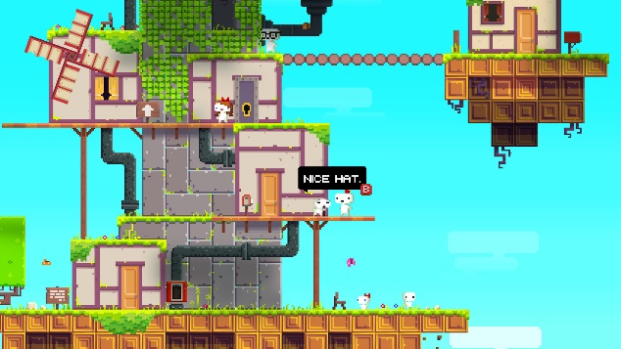**References**

Inspiration has been taken from the following:

**Fez and Perspective:**

These are platformers set in a 3D world, both of which can be viewed from a perspective that makes them look 2D.

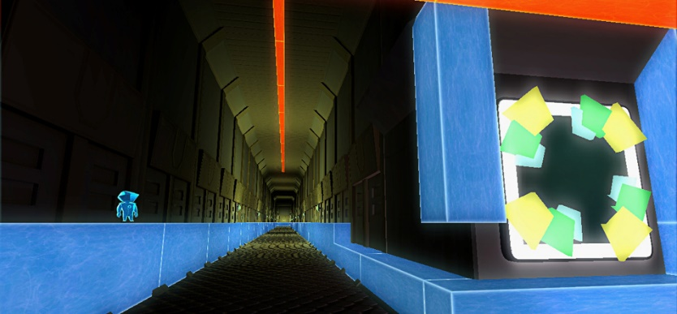In Fez, you can shift the perspective, which changes the (perceived) structure of the level.

In Perspective, your position and point of view change the 2D structure of the level.

**Portal**

Portal features the portal gun, which is the main tool for solving puzzles within the rooms

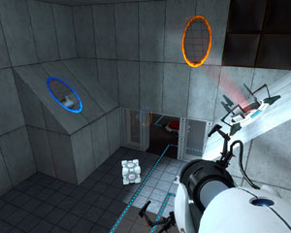The portal gun shoots two portals which you can teleport between. You must use knowledge of 3D space and portal mechanics to solve puzzles.

**Archaica**

Archaica focuses on transmitting and reflecting light in such a way as to get it to power crystals.

You must use the tools at your distrubution to direct the light into specific locations in the level.

**Adaptation of these concepts**

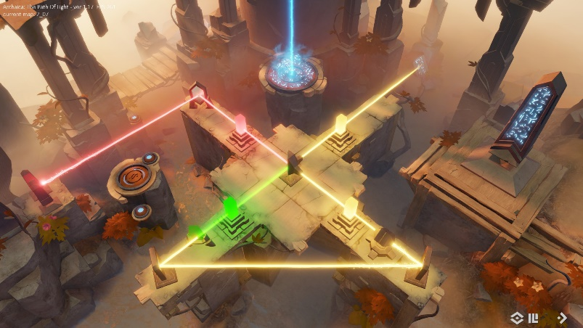Both Fez and Perspective use the idea of changing perspective to solve puzzles. This challenges the player to think both in 3D and 2D, and make a connection between the two.

Archaica presents the challenge of picturing the trajectory of light, foreseeing how it will behave. This is key to solving the puzzle.

Portal has a similar concept. You must visualise how placement of the portals will affect where you and other objects can go in the room.

This game combines these concepts together as well as implementing its own rules on behaviour of light, that are slightly more complex. The player must use their spatial awareness and understanding of the behaviour of light, both in 2D and 3D to solve puzzles in the game.

**Art**

**Focus:**

The game has a heavy focus on the puzzle solving element. The visuals should not distract the player from solving the puzzle. This doesn’t mean that they can’t be detailed, but rather that they should not be cluttered.

**Theme:**

The concept of the game is based on the behaviour of light in physics. This is a scientific theory. The themes associated with this are: futuristic, si-fi, technological etc. The art should adhere to this.

**Colour palette:**

A set of simple colours that can be easily differentiated from each other should be chosen. Each colour should represent a classifiable element of the game such as the beam, the goal and obstacles. This is so that they are easily identifiable. This way, the focus can remain on the puzzle.

Colours of elements making up the room should be clean, providing the sensation of everything being “new”, providing a futuristic look. The beam should be vibrant and luminous to be associated with light (like from a laser gun).

**Architecture and textures:**

Obstacles must be suited for light to correctly interact with them. This means that they should be formed of mostly flat surfaces. They can’t have too much complexity, because it will be very difficult to predict how light will interact with them, potentially overwhelming the player. Therefore, it is better to keep them simple.

The textures/materials of the obstacles should reflect the properties of the material they represent in real life. This is so that the player can intuitively understand how the beam will interact with them. For example, an obstacle that can reflect the beam should look like a mirror. Similarly, an obstacle that can refract the beam should look like glass.

Other elements of the level should look like they are technologically advanced, but also have a minimalist look to them. An example of what a room could look like is shown:

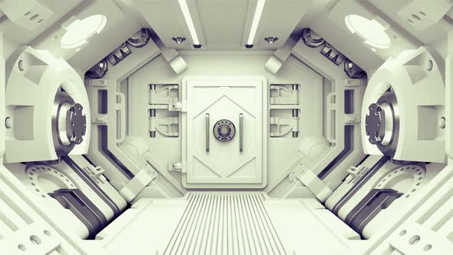

**Sound**

Similarly to the art, the sound in the game shouldn’t distract the player from the puzzle. In fact, it should create an atmosphere where the player is encouraged to focus and keep playing the game.

**Sound effects:**

Sound effects should give feedback to the player on what is going on in the game. For example, a sound effect resembling a laser shooting sound should be played when the player shoots the beam.

**Background Music**

The background music should relax the player. This will take away from the stress that is induced by attempting to solve the puzzle. While the game challenges the player, it has no element that forces the player to act quickly. The player should know that they can progress through this game at their own pace. The music will help attune the players mindset to this.

There are certain genres that seem to improve focus and lengthen attention span. Some genres induce a relaxed state in the listener. One genre that fits this description is ambient music. Not only is the genre quite relaxing, but it is also associated with the cosmos, which ties in with the sci-fi / futuristic theme. Music from this genre will be used as bgm.

**Mechanics**

**Player movement, aiming and shooting:**

* The player may move forwards, backwards, left and right
* The player can look around, up and down.
* The player can shoot a beam, emitting it from (approximately) his position, in the direction they’re facing
* A beam can only be shot if there are no beams present in the room.

**Obstacle properties:**

1. Beams that collide with an obstacle will either refract or reflect off that obstacle.
2. All obstacles have a “reflectivity”. This is a number which determines the minimum angle for reflection to occur. If reflection doesn’t occur, then refraction will.
3. All obstacles have a “refractive index”. This is a number which determines the change in direction of the beam when entering the obstacle.

**Beam properties:**

1. Beams move at a constant speed in a straight line unless acted upon
2. Upon colliding with an obstacle, the beam will either reflect or refract.
3. Upon moving closely past a corner or edge of an obstacle, the beam will turn slightly towards the obstacle
4. Each beam has a lifespan. When they’re shot it starts counting down with time. When their lifespan reaches zero, they disappear.

**Start and Winning:**

1. There is an ordered array of rooms in the game. All of them are locked, except for the first.
2. The player is placed inside a room (the first room if starting a new game). In each room there is a goal.
3. The goal is an object. If a beam collides with the goal, the room is considered complete. This unlocks the next room in the array. The player can then access that room.

**User Interface**

* The game is automatically saved upon completing a room
* Upon launching the game, the main menu is shown to the player. This has 5 buttons:
  + Continue – loads the last unlocked room
  + Room select – Shows a menu with all rooms. The player can access rooms that they’ve completed in the past. Other rooms are marked locked.
  + Options – Allows the player to adjust some options such as volume
  + Controls – Shows the controls to the player
  + Exit – Exits the game
* The game can be paused. The pause menu is almost identical to the main menu, with two differences: “continue” is replaced with resume, which un-pauses the game, and exit goes back to the main menu instead of exiting the game.

**Summary**

This is a first-person 3D puzzle game where the player must shoot a beam in such a way that it reaches a goal. The game is made up of unique rooms. Each room contains a unique set of obstacles which make it harder to shoot the beam towards the goal. The beam can reflect, refract and diffract off obstacles.

The player must make use of the beams properties as well as the obstacles’ properties to shoot the beam to the goal. They may also use two additional perspectives (top-down and sideways view) of the room to help them understand the beams trajectory and solve the level.